EECNN
/tmp/ipython-input-580082470.py:7: FutureWarning: `torch.cuda.amp.GradScaler(args...)` is deprecated. Please use `torch.amp.GradScaler('cuda', args...)` instead.
scaler = GradScaler()
Epoch 1/50: 0%| | 0/192 [00:00<?, ?it/s]/tmp/ipython-input-580082470.py:24: FutureWarning: `torch.cuda.amp.autocast(args...)` is deprecated. Please use `torch.amp.autocast('cuda', args...)` instead.
with autocast():

Epoch [1/50] Train Loss: 18.4054, Train Acc: 18.38%
/tmp/ipython-input-580082470.py:54: FutureWarning: `torch.cuda.amp.autocast(args...)` is deprecated. Please use `torch.amp.autocast('cuda', args...)` instead.
with autocast(): # ✅ use mixed precision in eval too
Validation Loss: 4.8869, Acc: 29.43%
✅ Best model saved (Epoch 1, Val Acc: 29.43%)
Current LR: 0.000500

Epoch [2/50] Train Loss: 4.6712, Train Acc: 23.34%
Validation Loss: 2.5685, Acc: 35.40%
✅ Best model saved (Epoch 2, Val Acc: 35.40%)
Current LR: 0.000498

Epoch [3/50] Train Loss: 2.5517, Train Acc: 27.32%
Validation Loss: 2.2235, Acc: 45.60%
✅ Best model saved (Epoch 3, Val Acc: 45.60%)
Current LR: 0.000496

Epoch [4/50] Train Loss: 2.1977, Train Acc: 30.26%
Validation Loss: 3.0388, Acc: 23.27%
Current LR: 0.000492

Epoch [5/50] Train Loss: 2.0432, Train Acc: 34.70%
Validation Loss: 2.2120, Acc: 39.77%
Current LR: 0.000488

Epoch [6/50] Train Loss: 1.9288, Train Acc: 37.31%
Validation Loss: 2.2036, Acc: 42.50%
Current LR: 0.000482

Epoch [7/50] Train Loss: 1.8828, Train Acc: 39.37%
Validation Loss: 2.2136, Acc: 42.18%
Current LR: 0.000476

Epoch [8/50] Train Loss: 1.8469, Train Acc: 41.11%
Validation Loss: 2.2705, Acc: 33.96%
Current LR: 0.000469

Epoch [9/50] Train Loss: 1.8074, Train Acc: 44.19%
Validation Loss: 2.0870, Acc: 44.62%
Current LR: 0.000461

Epoch [10/50] Train Loss: 1.7787, Train Acc: 45.40%
Validation Loss: 2.1404, Acc: 48.04%
✅ Best model saved (Epoch 10, Val Acc: 48.04%)
Current LR: 0.000452

Epoch [11/50] Train Loss: 1.7570, Train Acc: 45.99%
Validation Loss: 2.0883, Acc: 50.62%
✅ Best model saved (Epoch 11, Val Acc: 50.62%)
Current LR: 0.000443

Epoch [12/50] Train Loss: 1.7308, Train Acc: 48.17%
Validation Loss: 2.2234, Acc: 37.26%
Current LR: 0.000432

Epoch [13/50] Train Loss: 1.7176, Train Acc: 48.62%
Validation Loss: 2.0090, Acc: 50.75%
✅ Best model saved (Epoch 13, Val Acc: 50.75%)
Current LR: 0.000421

Epoch [14/50] Train Loss: 1.7032, Train Acc: 49.06%
Validation Loss: 2.1766, Acc: 40.29%
Current LR: 0.000409

Epoch [15/50] Train Loss: 1.6798, Train Acc: 50.63%
Validation Loss: 1.9765, Acc: 54.50%
✅ Best model saved (Epoch 15, Val Acc: 54.50%)
Current LR: 0.000397

Epoch [16/50] Train Loss: 1.6709, Train Acc: 51.85%
Validation Loss: 2.0470, Acc: 46.84%
Current LR: 0.000384

Epoch [17/50] Train Loss: 1.6546, Train Acc: 51.56%
Validation Loss: 1.9840, Acc: 56.39%
✅ Best model saved (Epoch 17, Val Acc: 56.39%)
Current LR: 0.000370

Epoch [18/50] Train Loss: 1.6318, Train Acc: 53.53%
Validation Loss: 2.1194, Acc: 43.42%
Current LR: 0.000356

Epoch [19/50] Train Loss: 1.6226, Train Acc: 52.92%
Validation Loss: 1.9490, Acc: 57.95%
✅ Best model saved (Epoch 19, Val Acc: 57.95%)
Current LR: 0.000342

Epoch [20/50] Train Loss: 1.6018, Train Acc: 55.17%
Validation Loss: 2.0427, Acc: 50.55%
Current LR: 0.000327

Epoch [21/50] Train Loss: 1.5968, Train Acc: 55.93%
Validation Loss: 2.0241, Acc: 47.46%
Current LR: 0.000312

Epoch [22/50] Train Loss: 1.5861, Train Acc: 55.57%
Validation Loss: 1.8905, Acc: 61.21%
✅ Best model saved (Epoch 22, Val Acc: 61.21%)
Current LR: 0.000297

Epoch [23/50] Train Loss: 1.5575, Train Acc: 57.43%
Validation Loss: 1.8628, Acc: 63.07%
✅ Best model saved (Epoch 23, Val Acc: 63.07%)
Current LR: 0.000281

Epoch [24/50] Train Loss: 1.5576, Train Acc: 57.30%
Validation Loss: 1.9882, Acc: 50.88%
Current LR: 0.000266

Epoch [25/50] Train Loss: 1.5468, Train Acc: 58.79%
Validation Loss: 1.9056, Acc: 61.08%
Current LR: 0.000250

Epoch [26/50] Train Loss: 1.5193, Train Acc: 59.18%
Validation Loss: 1.8793, Acc: 60.27%
Current LR: 0.000234

Epoch [27/50] Train Loss: 1.5193, Train Acc: 60.26%
Validation Loss: 1.9032, Acc: 61.51%
Current LR: 0.000219

Epoch [28/50] Train Loss: 1.4949, Train Acc: 61.33%
Validation Loss: 1.8769, Acc: 60.46%
Current LR: 0.000203

Epoch [29/50] Train Loss: 1.4845, Train Acc: 61.38%
Validation Loss: 1.9178, Acc: 58.08%
Current LR: 0.000188

Epoch [30/50] Train Loss: 1.4644, Train Acc: 63.15%
Validation Loss: 1.9388, Acc: 57.33%
Current LR: 0.000173

Epoch [31/50] Train Loss: 1.4485, Train Acc: 63.69%
Validation Loss: 1.8719, Acc: 62.06%
Current LR: 0.000158

Epoch [32/50] Train Loss: 1.4301, Train Acc: 64.54%
Validation Loss: 1.8452, Acc: 64.18%
✅ Best model saved (Epoch 32, Val Acc: 64.18%)
Current LR: 0.000144

Epoch [33/50] Train Loss: 1.4293, Train Acc: 65.01%
Validation Loss: 1.9319, Acc: 55.87%
Current LR: 0.000130

Epoch [34/50] Train Loss: 1.4071, Train Acc: 66.09%
Validation Loss: 1.8391, Acc: 65.48%
✅ Best model saved (Epoch 34, Val Acc: 65.48%)
Current LR: 0.000116

Epoch [35/50] Train Loss: 1.3838, Train Acc: 66.45%
Validation Loss: 1.8547, Acc: 63.20%
Current LR: 0.000103

Epoch [36/50] Train Loss: 1.3750, Train Acc: 67.24%
Validation Loss: 1.8314, Acc: 64.77%
Current LR: 0.000091

Epoch [37/50] Train Loss: 1.3662, Train Acc: 67.58%
Validation Loss: 1.8580, Acc: 63.92%
Current LR: 0.000079

Epoch [38/50] Train Loss: 1.3476, Train Acc: 68.66%
Validation Loss: 1.9106, Acc: 58.74%
Current LR: 0.000068

Epoch [39/50] Train Loss: 1.3358, Train Acc: 69.79%
Validation Loss: 1.8260, Acc: 64.99%
Current LR: 0.000057

Epoch [40/50] Train Loss: 1.3194, Train Acc: 70.13%
Validation Loss: 1.8133, Acc: 66.82%
✅ Best model saved (Epoch 40, Val Acc: 66.82%)
Current LR: 0.000048

Epoch [41/50] Train Loss: 1.3202, Train Acc: 70.09%
Validation Loss: 1.8223, Acc: 65.48%
Current LR: 0.000039

Epoch [42/50] Train Loss: 1.2989, Train Acc: 70.84%
Validation Loss: 1.8190, Acc: 66.00%
Current LR: 0.000031

Epoch [43/50] Train Loss: 1.2926, Train Acc: 71.62%
Validation Loss: 1.8196, Acc: 65.55%
Current LR: 0.000024

Epoch [44/50] Train Loss: 1.2807, Train Acc: 72.03%
Validation Loss: 1.8160, Acc: 65.94%
Current LR: 0.000018

Epoch [45/50] Train Loss: 1.2745, Train Acc: 72.08%
Validation Loss: 1.8056, Acc: 67.18%
✅ Best model saved (Epoch 45, Val Acc: 67.18%)
Current LR: 0.000012

Epoch [46/50] Train Loss: 1.2684, Train Acc: 72.85%
Validation Loss: 1.8075, Acc: 66.92%
Current LR: 0.000008

Epoch [47/50] Train Loss: 1.2666, Train Acc: 72.66%
Validation Loss: 1.7984, Acc: 66.69%
Current LR: 0.000004

Epoch [48/50] Train Loss: 1.2601, Train Acc: 73.22%
Validation Loss: 1.8025, Acc: 67.18%
Current LR: 0.000002

Epoch [49/50] Train Loss: 1.2622, Train Acc: 73.39%
Validation Loss: 1.8016, Acc: 66.95%
Current LR: 0.000000

Epoch [50/50] Train Loss: 1.2599, Train Acc: 73.28%
Validation Loss: 1.8040, Acc: 67.05%
Current LR: 0.000000

Training finished! Best Validation Accuracy: 67.18%
—--------------------------------
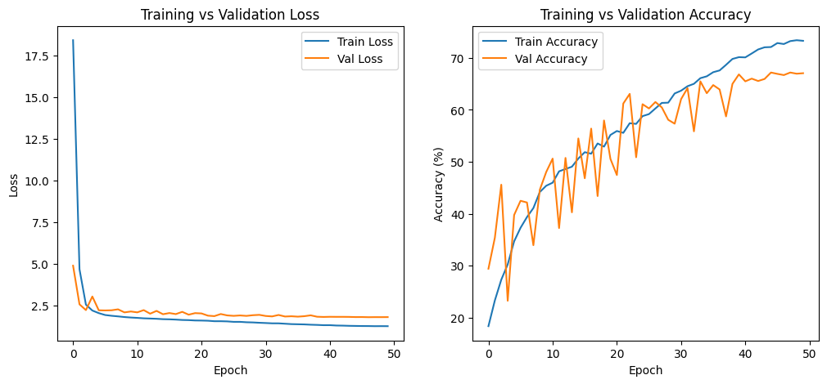
—---------------------------------------
precision recall f1-score support

1 0.7688 0.7781 0.7734 329
2 0.1903 0.6892 0.2982 74
3 0.3015 0.6312 0.4081 160
4 0.9909 0.6422 0.7793 1185
5 0.6550 0.7071 0.6801 478
6 0.4076 0.7901 0.5378 162
7 0.7978 0.6265 0.7018 680

accuracy 0.6718 3068
macro avg 0.5874 0.6949 0.5970 3068
weighted avg 0.7859 0.6718 0.7023 3068

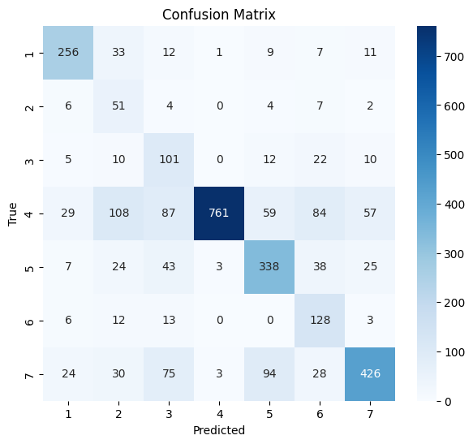

EECNN + ResNet

Train Epoch 1: 100%|██████████| 384/384 [01:09<00:00, 5.53it/s]
Epoch 1 | Train Acc: 33.22% | Val Acc: 51.56%
🔥 Saved best model: 51.56%
Train Epoch 2: 100%|██████████| 384/384 [01:02<00:00, 6.17it/s]
Epoch 2 | Train Acc: 57.86% | Val Acc: 60.69%
🔥 Saved best model: 60.69%
Train Epoch 3: 100%|██████████| 384/384 [01:06<00:00, 5.81it/s]
Epoch 3 | Train Acc: 64.40% | Val Acc: 70.93%
🔥 Saved best model: 70.93%
Train Epoch 4: 100%|██████████| 384/384 [01:03<00:00, 6.05it/s]
Epoch 4 | Train Acc: 69.74% | Val Acc: 67.14%
Train Epoch 5: 100%|██████████| 384/384 [01:00<00:00, 6.32it/s]
Epoch 5 | Train Acc: 71.30% | Val Acc: 72.26%
🔥 Saved best model: 72.26%
Train Epoch 6: 100%|██████████| 384/384 [01:03<00:00, 6.06it/s]
Epoch 6 | Train Acc: 74.40% | Val Acc: 76.56%
🔥 Saved best model: 76.56%
Train Epoch 7: 100%|██████████| 384/384 [01:02<00:00, 6.11it/s]
Epoch 7 | Train Acc: 76.30% | Val Acc: 70.96%
Train Epoch 8: 100%|██████████| 384/384 [01:01<00:00, 6.20it/s]
Epoch 8 | Train Acc: 77.88% | Val Acc: 73.47%
Train Epoch 9: 100%|██████████| 384/384 [01:00<00:00, 6.32it/s]
Epoch 9 | Train Acc: 79.74% | Val Acc: 77.87%
🔥 Saved best model: 77.87%
Train Epoch 10: 100%|██████████| 384/384 [01:03<00:00, 6.01it/s]
Epoch 10 | Train Acc: 81.43% | Val Acc: 74.38%
Train Epoch 11: 100%|██████████| 384/384 [01:00<00:00, 6.38it/s]
Epoch 11 | Train Acc: 82.58% | Val Acc: 76.53%
Train Epoch 12: 100%|██████████| 384/384 [01:00<00:00, 6.34it/s]
Epoch 12 | Train Acc: 84.50% | Val Acc: 79.99%
🔥 Saved best model: 79.99%
Train Epoch 13: 100%|██████████| 384/384 [01:02<00:00, 6.15it/s]
Epoch 13 | Train Acc: 85.82% | Val Acc: 77.48%
Train Epoch 14: 100%|██████████| 384/384 [00:59<00:00, 6.48it/s]
Epoch 14 | Train Acc: 87.74% | Val Acc: 79.66%
Train Epoch 15: 100%|██████████| 384/384 [01:00<00:00, 6.31it/s]
Epoch 15 | Train Acc: 88.52% | Val Acc: 81.16%
🔥 Saved best model: 81.16%
Train Epoch 16: 100%|██████████| 384/384 [01:00<00:00, 6.31it/s]
Epoch 16 | Train Acc: 90.01% | Val Acc: 82.07%
🔥 Saved best model: 82.07%
Train Epoch 17: 100%|██████████| 384/384 [01:02<00:00, 6.16it/s]
Epoch 17 | Train Acc: 91.37% | Val Acc: 80.25%
Train Epoch 18: 100%|██████████| 384/384 [01:00<00:00, 6.36it/s]
Epoch 18 | Train Acc: 92.24% | Val Acc: 79.82%
Train Epoch 19: 100%|██████████| 384/384 [01:00<00:00, 6.38it/s]
Epoch 19 | Train Acc: 93.54% | Val Acc: 81.52%
Train Epoch 20: 100%|██████████| 384/384 [01:00<00:00, 6.35it/s]
Epoch 20 | Train Acc: 94.47% | Val Acc: 82.37%
🔥 Saved best model: 82.37%
Train Epoch 21: 100%|██████████| 384/384 [01:01<00:00, 6.25it/s]
Epoch 21 | Train Acc: 94.91% | Val Acc: 82.43%
🔥 Saved best model: 82.43%
Train Epoch 22: 100%|██████████| 384/384 [01:03<00:00, 6.09it/s]
Epoch 22 | Train Acc: 96.19% | Val Acc: 82.92%
🔥 Saved best model: 82.92%
Train Epoch 23: 100%|██████████| 384/384 [01:01<00:00, 6.20it/s]
Epoch 23 | Train Acc: 96.52% | Val Acc: 82.56%
Train Epoch 24: 100%|██████████| 384/384 [01:02<00:00, 6.16it/s]
Epoch 24 | Train Acc: 97.02% | Val Acc: 82.30%
Train Epoch 25: 100%|██████████| 384/384 [01:00<00:00, 6.38it/s]
Epoch 25 | Train Acc: 97.13% | Val Acc: 83.12%
🔥 Saved best model: 83.12%
Train Epoch 26: 100%|██████████| 384/384 [01:02<00:00, 6.14it/s]
Epoch 26 | Train Acc: 97.73% | Val Acc: 83.51%
🔥 Saved best model: 83.51%
Train Epoch 27: 100%|██████████| 384/384 [01:02<00:00, 6.14it/s]
Epoch 27 | Train Acc: 97.71% | Val Acc: 83.28%
Train Epoch 28: 100%|██████████| 384/384 [01:00<00:00, 6.35it/s]
Epoch 28 | Train Acc: 98.14% | Val Acc: 83.70%
🔥 Saved best model: 83.70%
Train Epoch 29: 100%|██████████| 384/384 [01:01<00:00, 6.24it/s]
Epoch 29 | Train Acc: 98.10% | Val Acc: 83.51%
Train Epoch 30: 100%|██████████| 384/384 [01:01<00:00, 6.29it/s]
Epoch 30 | Train Acc: 98.13% | Val Acc: 83.41%

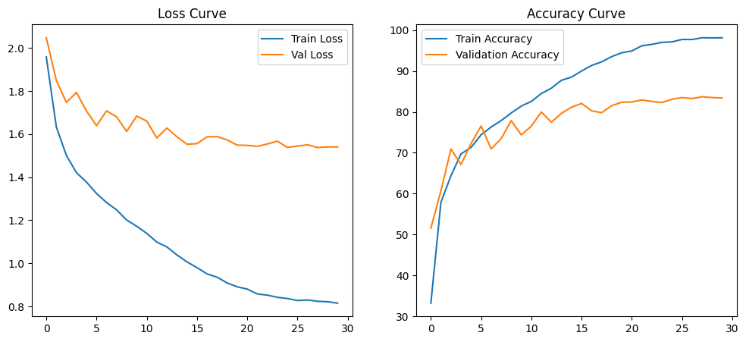

precision recall f1-score support

1 0.82 0.85 0.83 329
2 0.61 0.55 0.58 74
3 0.55 0.59 0.57 160
4 0.94 0.91 0.93 1185
5 0.82 0.78 0.80 478
6 0.77 0.76 0.76 162
7 0.80 0.85 0.82 680

accuracy 0.84 3068
macro avg 0.76 0.76 0.76 3068
weighted avg 0.84 0.84 0.84 3068

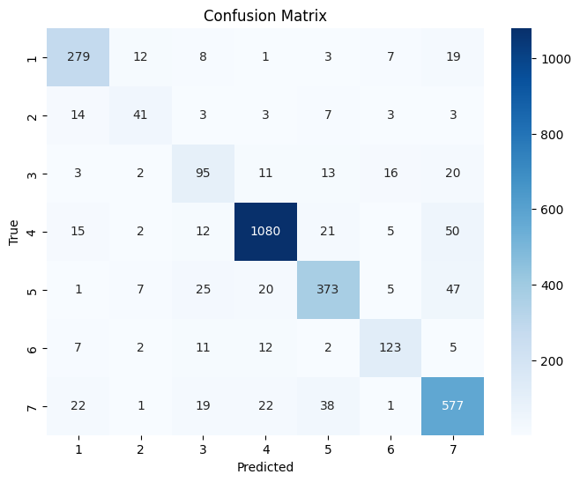

PM-Vit - AffectNet
Epoch 1: Train Loss 1.2148 | Train Acc 54.02% | Val Acc 59.80%
🔥 New best PM-ViT model saved with Val Acc = 59.80%
Epoch 2: Train Loss 0.9207 | Train Acc 65.25% | Val Acc 61.32%
🔥 New best PM-ViT model saved with Val Acc = 61.32%
Epoch 3: Train Loss 0.7979 | Train Acc 70.48% | Val Acc 62.84%
🔥 New best PM-ViT model saved with Val Acc = 62.84%
Epoch 4: Train Loss 0.6794 | Train Acc 74.76% | Val Acc 63.30%
🔥 New best PM-ViT model saved with Val Acc = 63.30%
Epoch 5: Train Loss 0.5768 | Train Acc 78.58% | Val Acc 62.40%
Epoch 6: Train Loss 0.4738 | Train Acc 82.63% | Val Acc 62.03%
Epoch 7: Train Loss 0.3967 | Train Acc 85.91% | Val Acc 59.36%
Epoch 8: Train Loss 0.3243 | Train Acc 88.10% | Val Acc 62.96%
Epoch 9: Train Loss 0.2274 | Train Acc 91.84% | Val Acc 62.65%
Epoch 10: Train Loss 0.2124 | Train Acc 92.45% | Val Acc 61.91%

anger 0.55 0.42 0.48 1718
contempt 0.80 0.41 0.54 1312
disgust 0.44 0.44 0.44 1248
fear 0.55 0.50 0.52 1664
happy 0.87 0.86 0.87 2704
neutral 0.71 0.90 0.79 2368
sad 0.48 0.81 0.61 1584
surprise 0.48 0.37 0.42 1920

accuracy 0.63 14518
macro avg 0.61 0.59 0.58 14518
weighted avg 0.63 0.63 0.62 14518

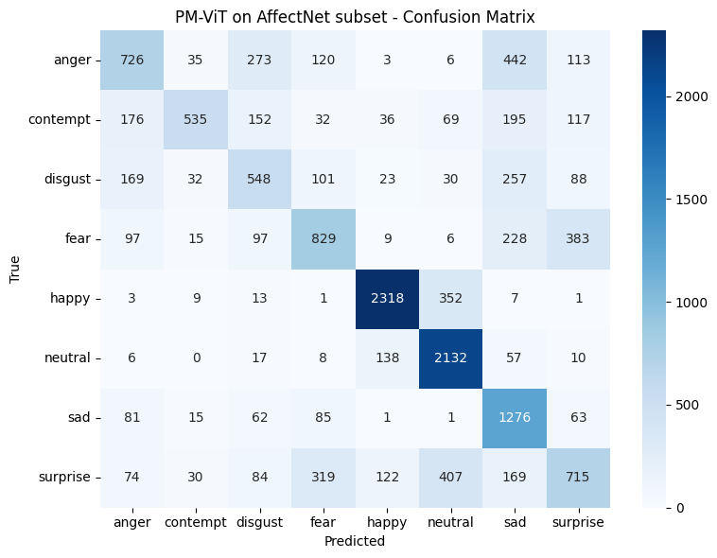

POSTER
Epoch 1/10: 100%|██████████| 192/192 [02:51<00:00, 1.12it/s]
Epoch [1/10] Loss: 0.7115
Validating: 100%|██████████| 48/48 [00:15<00:00, 3.14it/s]
Validation Accuracy: 0.7816
🔥 New Best Model Saved! Accuracy: 0.7816
Epoch 2/10: 100%|██████████| 192/192 [02:52<00:00, 1.11it/s]
Epoch [2/10] Loss: 0.4431
Validating: 100%|██████████| 48/48 [00:15<00:00, 3.17it/s]
Validation Accuracy: 0.8576
🔥 New Best Model Saved! Accuracy: 0.8576
Epoch 3/10: 100%|██████████| 192/192 [02:53<00:00, 1.11it/s]
Epoch [3/10] Loss: 0.3385
Validating: 100%|██████████| 48/48 [00:15<00:00, 3.16it/s]
Validation Accuracy: 0.8605
🔥 New Best Model Saved! Accuracy: 0.8605
Epoch 4/10: 100%|██████████| 192/192 [02:53<00:00, 1.11it/s]
Epoch [4/10] Loss: 0.2604
Validating: 100%|██████████| 48/48 [00:15<00:00, 3.12it/s]
Validation Accuracy: 0.8481
No improvement.
Epoch 5/10: 100%|██████████| 192/192 [02:51<00:00, 1.12it/s]
Epoch [5/10] Loss: 0.1755
Validating: 100%|██████████| 48/48 [00:15<00:00, 3.18it/s]
Validation Accuracy: 0.8556
No improvement.
Epoch 6/10: 100%|██████████| 192/192 [02:51<00:00, 1.12it/s]
Epoch [6/10] Loss: 0.1221
Validating: 100%|██████████| 48/48 [00:15<00:00, 3.10it/s]
Validation Accuracy: 0.8823
🔥 New Best Model Saved! Accuracy: 0.8823
Epoch 7/10: 100%|██████████| 192/192 [02:52<00:00, 1.11it/s]
Epoch [7/10] Loss: 0.0749
Validating: 100%|██████████| 48/48 [00:15<00:00, 3.15it/s]
Validation Accuracy: 0.8875
🔥 New Best Model Saved! Accuracy: 0.8875
Epoch 8/10: 100%|██████████| 192/192 [02:53<00:00, 1.10it/s]
Epoch [8/10] Loss: 0.0403
Validating: 100%|██████████| 48/48 [00:15<00:00, 3.14it/s]
Validation Accuracy: 0.8944
🔥 New Best Model Saved! Accuracy: 0.8944
Epoch 9/10: 100%|██████████| 192/192 [02:52<00:00, 1.11it/s]
Epoch [9/10] Loss: 0.0240
Validating: 100%|██████████| 48/48 [00:15<00:00, 3.18it/s]
Validation Accuracy: 0.9016
🔥 New Best Model Saved! Accuracy: 0.9016
Epoch 10/10: 100%|██████████| 192/192 [02:52<00:00, 1.11it/s]
Epoch [10/10] Loss: 0.0166
Validating: 100%|██████████| 48/48 [00:15<00:00, 3.11it/s]
Validation Accuracy: 0.9022
🔥 New Best Model Saved! Accuracy: 0.9022
Training complete!
Best accuracy achieved: 0.9022

CLASSIFICATION REPORT (POSTER on RAF-DB)
------------------------------------------------------------
Class Precision Recall F1-score Support
------------------------------------------------------------
surprise 0.8916 0.8997 0.8956 329
fear 0.7538 0.6622 0.7050 74
disgust 0.7748 0.7312 0.7524 160
happy 0.9645 0.9629 0.9637 1185
sad 0.8671 0.8870 0.8769 478
anger 0.8710 0.8333 0.8517 162
neutral 0.8745 0.8912 0.8827 680

accuracy 0.9022 3068
macro avg 0.8567 0.8382 0.8469 3068
weighted avg0.9016 0.9022 0.9018 3068

